Student numbers: g19G2085, g18S6973, g18C4646

Title: European Blackjack

Background and Motivation:

Blackjack is a card game played with one or more standard decks of 52 cards. In European blackjack 2 standard 52-card decks are usually used, where reshuffling of cards occurs after every round, to avoid card-counting. Each card, ace through king are given values. Cards 2 to 10 have the values corresponding to their numbers. Jack, Queen and King have values of 10. Ace can be valued 1 or 11 depending on the scenario (explained later). The player sets a wager/bet and is given two cards and the dealer is given one card, (Blackjack.org, 2019). The objective for the player to win is to have cards with a sum value closer to, but not greater than 21, when compared to the sum value of the dealer’s cards. The player can request a ‘hit’, which means the dealer gives them an extra card, thus increasing their sum value. The player can keep calling for a hit while their set of cards’ sum value is less than 21. Should their sum value be greater than 21, it is called a ‘bust’ and the dealer wins, therefore meaning the player forfeits their bet/wager. If the score is less than 21 and the player calls a ‘stand’, it means they are happy with their set of cards and can no longer request more. If their set of cards has a sum value equal to 21, their turn automatically stops. Given the player did not have a bust, the dealer then takes hits for their own set of cards until their score is greater than the players, a score of 21, a bust, or, if the dealer finds themselves on a value of 17 to 20, they must stand, (BlackJackInstitute, 2019). When the cards are dealt, both the dealer’s card and the player’s pair of cards are faceup. In terms of the ace, it is given the most suitable value depending on the scenario, for example, if a player is dealt a 9 and an ace, the ace will have value 1 or 11, depending on what the player decides next. If the player calls stand, the ace will have value 11 and their total will be 20, however if the player calls hit and receives a card valued 10, the ace will have value 1 to avoid a bust, meaning their total is 20, but if they request another hit and it is an ace, it will also be valued 1, giving a total of 21. If the initial pair consists of a 10 and a 9 and the player calls for a hit and receives an ace, it will be of value 1 and so on. Should the dealer and player end with the same score, the game ends, called a ‘push’, and neither party loses nor wins money, (Golden Riviera Casino, 2011).

A player can ‘split’ the two cards they are at first given into two separate sets of cards if the two initial cards both have a value of 10 or are both aces. Both new sets of cards hold a wager equivalent to the original bet by the player (their bet becomes double the original). The player then plays with each pair as separate sets, meaning they can play with each set as they would normally with one, so they can call hit, stand and get bust on each set. Once they are finished playing with one set, they move on to the next. For each set that beats the dealer, they win — if both sets beat the dealer, player win double the earnings they would have won under a normal win (or four times their original bet), but if only one set wins, neither party loses nor wins money. The same applies for losing sets, if the player loses on both sets, they lose double the amount they originally betted. ‘Doubling down’ is another option to players when their two initial cards have a total value of 9, 10 or 11. Doing this doubles the initial wager and the player is given one more card, after which they can no longer request anymore hits (Willets, 2017).

In terms of earnings, the player will usually receive a 1:1 reward for winning, meaning if they bet $10 and they did not split, double or have blackjack, they will earn $20, however it is different if the player’s initial cards consist of an ace and a 10 valued card (this is called a blackjack) or the player splits or doubles down and they end with a total higher than the dealers. If they did a double down their bet would become $20 and if they win, the reward will be $40. In the case of blackjack, they will receive a 3:2 reward for winning (they win if the dealer does not get blackjack as well), meaning if they had a bet of $10, they will earn $15. Important to note is that a set of cards totalling to 21 that is not an ace and a 10 valued card is not blackjack, a blackjack takes preference over a set with total 21. If the player has a hand of 21 and the dealer gets blackjack, the player loses, but only the amount of their original bet.

This variation of will be adopted in the game as it is a common variation in casinos, also, when compared to other versions of blackjack, it provides less room for cheating by card counting and it excludes features such as ‘surrender’, which is when the player can end the game before the dealer is dealt cards, thus meaning the player loses only half their bet. Only one deck will be used as opposed to two decks. Otherwise, all rules remain the same. The game will be for one player only.

History of the game:

Blackjack has origins in French and Spanish games called “Ving-et-un” (translated to ‘21’). The game was referenced by a well-known priest in 1440 and later by the Spaniard author Miguel de Cervantes, the author of the famous Don Quixote. When the game ‘21’ was introduced into the United States, an adaptation was made where players who were dealt an ace and black jack of clubs or black jack of spades received massive pay-outs, hence the name blackjack. Popularity of the game spiked when Ed Thorpe devised ‘card-counting’ techniques that gave the player a much better chance at beating the dealer, meaning more people would try their luck at the casinos (Ofton, 2019).

Problem Statement:

The aim of blackjack here is to be dealt cards that scores blackjack, or to have a set of cards with a higher total than the dealer’s set of cards. Winning means the player receives more money than what they bet. European blackjack must be properly implemented. This game has a medium complexity and will be designed to be attractive, user-friendly, fun and suit the casino.

Approach:

This project aims to implement a European blackjack card game in java with certain milestones. One person will be able play this game at a time with the computer as the dealer. That is, the player will be the one given two cards and the hit, split, stand and double options where applicable. The computer will play accordingly, once the player has finished. To make the game more fun, the player will start with a certain amount of cash and will place bets on each round. This amount will act as their score as it changes according to whether they win or lose (and how). The player can choose to end the game (or ‘walk away’) when they are happy with their amount or score, but if their score reaches 0, the game will end. There will be a minimum amount they can place as a bet, as well as a maximum. This game will be given a user-friendly and attractive graphical user interface (GUI) to make the game more appealing. The project will be given for assessment by GitHub code as well as a project document, which is a document that will revisit what is stated within this proposal, as well as any further details that need to be clarified. Further details will include the Software Development Life Cycle (SDLC) that the group followed (waterfall is intended) and a visual guide to present the game and all the stages and fundamental aspects of the game pictorially.

The first milestone (1) will be to code one array that is a 52-card deck, as well as a way to shuffle this and measure how well shuffled it is (Shannon entropy). The second milestone (2) will be to code a betting system for the player to place bets. The third milestone (3) will be a code for the dealer, dealing cards to the player and themselves, and displaying these given cards. The fourth milestone (4) will be a code for the player to make decisions, the dealer to react and the subsequent results of their choices. The fifth milestone (5) will be calculating the resultant scores. The sixth milestone (6) will be a finalised GUI and multiplayer, and the seventh milestone (7) will be project document completion. The final milestone (8) is submission of the project document and game code on GitHub.

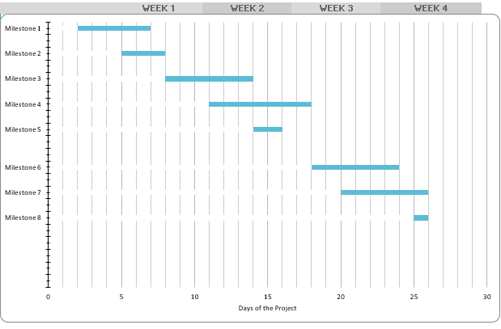

Timeline for the project for month of September, starting at 2 September:

References:

* Blackjack.org. (2019). *American Blackjack vs European Blackjack*. Retrieved from Blackjack.org: https://www.blackjack.org/resources/american-blackjack-vs-european-blackjack/
* BlackJackInstitute. (2019). *Master European Blackjack Now! Rules, Strategy, Betting, etc*. Retrieved from BlackJackInstitute: https://www.blackjackinstitute.com/blackjack-strategy-card/
* Golden Riviera Casino. (2011/10/21). *How To Play Blackjack* [Video File]. Retrieved from https://www.youtube.com/watch?v=-9YGKFdP6sY
* Ofton, L. (2019). *The History of Blackjack and Card Counting.* Retrieved from BLACKJACK APPRENTICESHIP: https://www.blackjackapprenticeship.com/the-history-of-blackjack-and-card-counting/
* Willets, T. (2017). *Difference between European Blackjack and American Blackjack*. Retrieved from SPINZWIN: https://www.spinzwin.com/difference-european-american-blackjack/